Boy Scout Troop 279

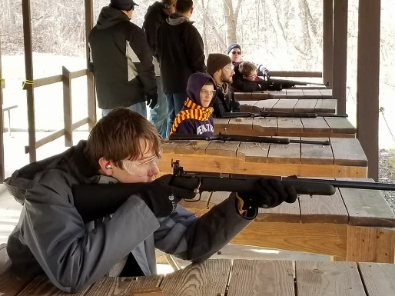
Troop 279 was founded in 1960 and has developed over 100 Eagles over that time, with over 40 under the current Scoutmaster Justin Sayre.
The troop currently has about 30 active members and we meet every Monday night (except holidays) from 7:00 to 8:30 at the Fraternal Order of the Eagle on Brice Road. If there is a 5th Monday in a month, that will usually be a “fun night,” like a Halloween party or trip to a trampoline park.

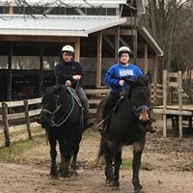
Troop 279 has camping excursions every month over the weekends and a week-long summer camp in June. All parents are invited to participate at all events and campouts. Campouts vary from $25 to $75 depending upon the destination. A list of this year’s campouts is listed on the last page of this packet.
In addition, Troop 279 also has plans a High Adventure trip every other year (in 2019, the troop will be visiting Gatlinburg / Pigeon Forge, TN). Past trips have included Gettysburg/Washington DC, Boston, Carnival Cruise from NYC to Canada, Niagara Falls)
For older scouts, ages 14-21, we also have a Venture Crew (Separate unit under the BSA). Crew’s are co-ed and have an emphasis on high adventure.
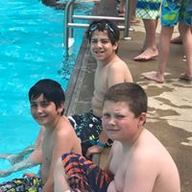
Like most Boy Scout Troops, meetings and campouts are boy-led. The Senior Patrol Leader is the top youth leader of the troop, and he organizes the other patrol leaders, assistant patrol leaders, quartermaster, and all other troop leaders in their activities both during troop meetings and at campouts.
Troop 279 dues are currently $100 per year, but there are several opportunities for fund raising “Scout Bucks”, either through popcorn sales, wreath sales, or working concessions at OSU events
Boy Scout Troop 279
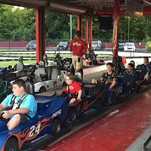
Our philosophy is very basic. We are here for the boys to learn and have a good time doing it. So what we do is to allow the boys to decide where they are going camping, what badges they are going to earn as a troop, and they plan the meetings and run them for the most part. We also stress Leadership. All the boys hold a leadership position at some point while in the troop.
We also like the boys to learn as much as they can or choose to. Between the Scoutmaster and the other adult leader’s, as well as the older scouts, we have a great amount of knowledge to share.
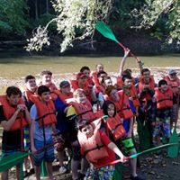
Most equipment is provided by the troop for campouts including tents, dining fly’s, food / utensils / cooking equipment, and supplies for activities.
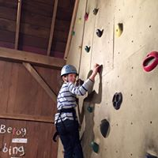
The equipment that the scout would need to supply are uniforms (BSA Field Uniform (aka Class A): Khaki BSA Shirt and Blue Jeans
BSA Activity Uniform (aka Class B) will be provided by the Troop (1 shirt in needed size) — more available for small price), The Boy Scout Handbook, a good sleeping bag, a backpack or duffel bag, and a flashlight.

This troop has had a lot of fun over the years and has made a difference in the community. Several Eagle projects have been completed in the past year, many with the help of several troop members. We encourage you to feel free to ask any questions and feel free to join us at any of our upcoming troop meetings or campouts.
Justinsayre80@gmail.com
Wbarry9999@gmail.com
Matt.mcintyre.pe@gmail.com
Boy Scouts of America
Troop 279

Reynoldsburg, Ohio 43068
Campout Schedule 2017-2018

Campouts:

September 29th, 30th, October 1st 2017

Cardboard Boats / Canoeing (Camp at Mohican Wilderness)

Cost: $40.00

October 13th, 14th, 15th 2017

Kings Island (Camp at Camp Craig - Grand Canyon Campsite)

Cost: $80.00

November 17th, 18th, 19th 2017 (Cabin)

Capture the Flag Competition (Camp at Camp Lazarus SM Cabin’s) *Webelo Invite*

Cost: $40.00

December 8th, 9th, 10th 2017 (Cabin)

Rifle Shooting (MVSR Staff Village Cabins)

Cost: $35.00

January 19th, 20th, 21st 2018 (Cabin)

Marmon Valley Farms (Camp at farm ~ Dudes Cabin & Log Cabin)

Cost: $95.00

February 16th, 17th, 18th 2018 (Cabin)

Snow Trails Tubing (Camp at Mohican State Park Cabins)

Cost: $80.00

March 10th, 11th 2018

COSI Overnight

Cost: $50.00

April 20th, 21st, 22nd 2018

Kelly’s Island or Put-in-Bay (Camp at East Harbor State Park)

Cost: $45.00

May 4th, 5th, 6th 2018

Thunderbase 2018 (Ross Co. Fairgrounds)

Cost: $45.00

Summer Camp: (June 24th – June 30th 2018)
Summer Camp (MVSR)

Cost: $ 280.00

August 10th, 11th, 12th 2018
Youth Leadership Retreat (Camp at Cricket Holler)

Cost: $45.00

